Installation of an e-mail footer
“We are participating in SIAMS 2024”

Proceed as follows to install an e-mail footer called “We are participating at SIAMS 2024”.

Open a new e-mail window and select “Signatures”.

Click on “Signatures” and select “New” in the window that opens:
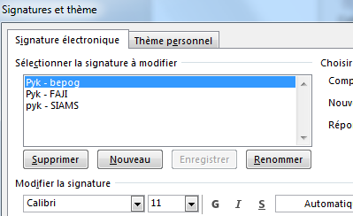

Give your new signature a name and confirm with OK: 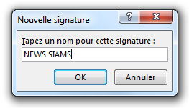

Copy the box below (text and logo).

We are participating in SIAMS 2024 at Stand XX

And paste it into the “Signature” window:

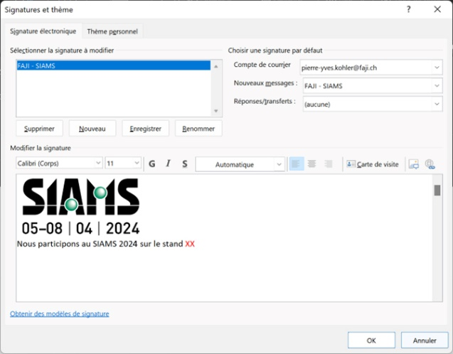
Add your stand number instead of XX

Click on “OK” at bottom right: 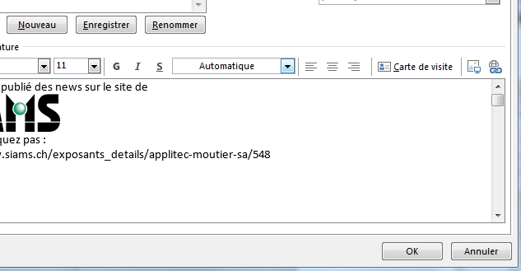
You can now send your e-mails as usual and before sending them, select the newly created signature with the help of the “Signature” button as shown in Fig. 1 of this document.

