E-mail or letter
“Invitation to SIAMS 2024 in Moutier”

Subject: invitation to SIAMS 2024 in Moutier

Dear customer

From April 16th to 19nd, 2024, Moutier (Bernese Jura, Switzerland) will be transformed into the world capital of micro and precision engineering. However, although the fair has continually increased, it is still easy to take in and allows us to optimally present ourselves in a hospitable and friendly ambiance.

We are pleased to inform you of our presence at this fair, which presents the entire production chain of microtechnology.

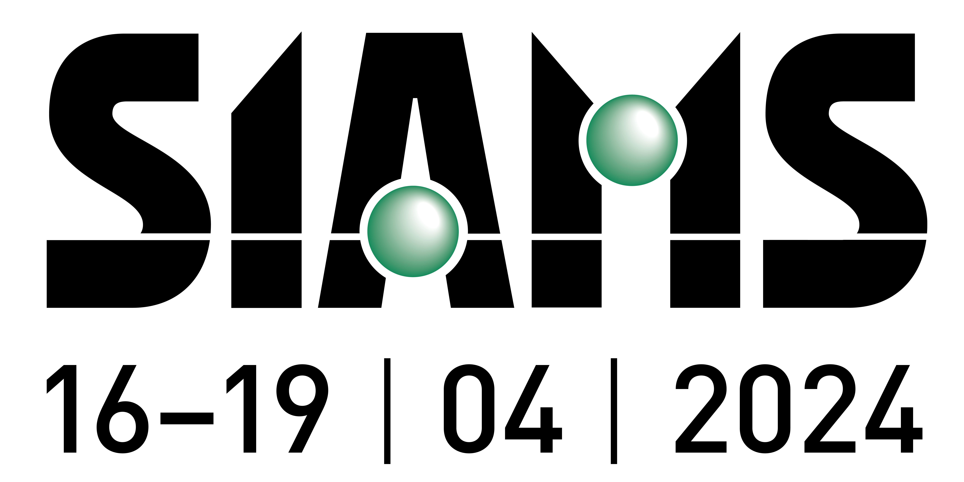

You will find us on booth XX in Hall YY.

We shall take advantage of our presence in the midst of this market to present products X or Y offering you the following advantages:
- advantage A
- advantage B

We are looking forward to meet you at this important event.

You can also put the link to your personalized homepage, see the tutorial here :
https://www.siams.ch/actualite/nouveau--page-d-accueil---et-d-invitation--personnalisee/4933?LanguageForce=EN

To simplify your visit, the organizers have set up a preparation system that allows you to “put your contacts in a basket” and print the list to take on site. Do not miss us.
Explanations available from: https://www.siams.ch/actualite/un-puissant-utilitaire-pour-planifier-votre-visite-a-siams/1049?LanguageForce=EN

Kind regards,

(Signature)

From February 15, 2024, you will be able to download your complimentary ticket from the SIAMS website: www.siams.ch/tickets

