Press release
SIAMS 2018 Article No. 5 2 mars 2018

Mission (im)possible : [M:I - SIAMS]
The first thing that the name of the Bronx in New York is reminiscent of, is certainly not precision machining. But right here, a few blocks from the Yankee Stadium, the turning company that we are dealing with was founded. In just a few years, as the market slowed down, the company tripled its workforce, moved to another neighbourhood and saw its results skyrocket. How did it achieve this?
Welcome to the New York City of irritable minorities and gangsters... But like everywhere else, the reality is not so clear-cut. According to New York historian Kenneth T. Jackson, “The Bronx remains the anteroom of success. This is where many ambitious immigrants begin their social rise.” But how can SIAMS get involved?

Mission (im)possible: find THE solution
“Customers always want better prices, and parts are steadily becoming more complex. The challenge is to find intelligent ways of making these parts so we can produce them before our competitors”, Hunt explained. Commissioned by his boss to find the best machining solution, Agent Hunt travelled throughout the United States and the world. From one thing to another, following hints, experiencing hope and disappointment, the specialist finally found himself in Moutier during SIAMS.

A discovery that changes everything
Accustomed to poker games in smoky backrooms, Hunt is not easily upset. He recalls: “It was as if I had walked through the door of a toy store. I was seven years old again and was allowed to buy everything, a dream come true.” He continued: “Keeping a cool head wasn’t easy; wherever I went, the exhibitors were friendly and wanted to help me produce parts faster, more efficiently, and without any problems... .” As a representative commissioned by his boss, he was completely free to enter into agreements and took advantage of this power.

A region with strong DNA
At the end of his visit, Hunt placed an order for machines, peripherals, consumables, accessories, and even additional equipment. He said: “I have visited trade fairs in many parts of the world, but only SIAMS unites all skills of the microtechnical production chain.” He added: “Many small manufacturers only communicate by way of SIAMS, so every two years the event is full of nuggets to be discovered.”

A comprehensive solution labelled SIAMS
“We are not the only company on the market that produces exceptional pieces. Somewhere out there are people who do it as well as we do, and that’s why one of our motivations is to always strive for excellence”, said Hunt and added: “Visiting SIAMS has really changed our lives. In just a few hours we were able to meet all the specialists we wanted and find a complete solution with the ‘SIAMS’ label, which also works in New York. Recently, the company has left the Bronx to move into new, much larger premises in the Nassau area, a few kilometres from its previous location. “Without the microtechnical solutions discovered at SIAMS, we should certainly still be a small workshop in the Bronx”, Hunt concluded.

Will Hunt be present in 2018?
Always looking for better solutions, Hunt summed up his approach: “My philosophy is as follows: no matter what shape the part has – round, square, or polygonal – we can make it if we can adapt it to the machine. We will find a way to circumvent restrictions.” To achieve this, technological monitoring is very important and SIAMS is one of the tools used by this specialist. He said: “I will be here in 2018! I already have my ticket and prepared my visit using the planning tool provided by the organizers. This utility has allowed me to list the most important suppliers I am going to visit first.” He concluded: “One of the strengths of SIAMS is its size. I'll be able to walk around the entire fair in a single day. A visit to SIAMS is definitely one of the best investments we can make.”

[[Box]]
Free admission and planning tool
Since 2016, admission is free of charge for all those who download their tickets from the Internet (www.siams.ch/tickets). This makes it easier for visitors to access the fair and for exhibitors, who can now also scan visitors' tickets, to respond more efficiently to them.
Visitors can prepare their visit to SIAMS in advance with the planning system set up by the organizers. Using a computer, from the exhibitor's directory or the list of exhibits or even from a detailed information on the exhibitor, they can simply add a company to their “visits to do” list by clicking on the “trombone” icon. Their visiting schedule is saved by the browser. Once the list is complete, it can be downloaded in PDF format or even added to their calendar. This list contains any company master data as well as the hall and stand numbers.
[[END]]

Interested in going further in microtechnology? Do not hesitate to do like Mr Hunt – 445 SIAMS exhibitors will be waiting for you in Moutier from April 17th till April 20th to help you find YOUR best solution.

With SIAMS, this has truly become a “Mission Possible”.
Moutier Arc Forum
April 17th – 20th, 2018

Pictures
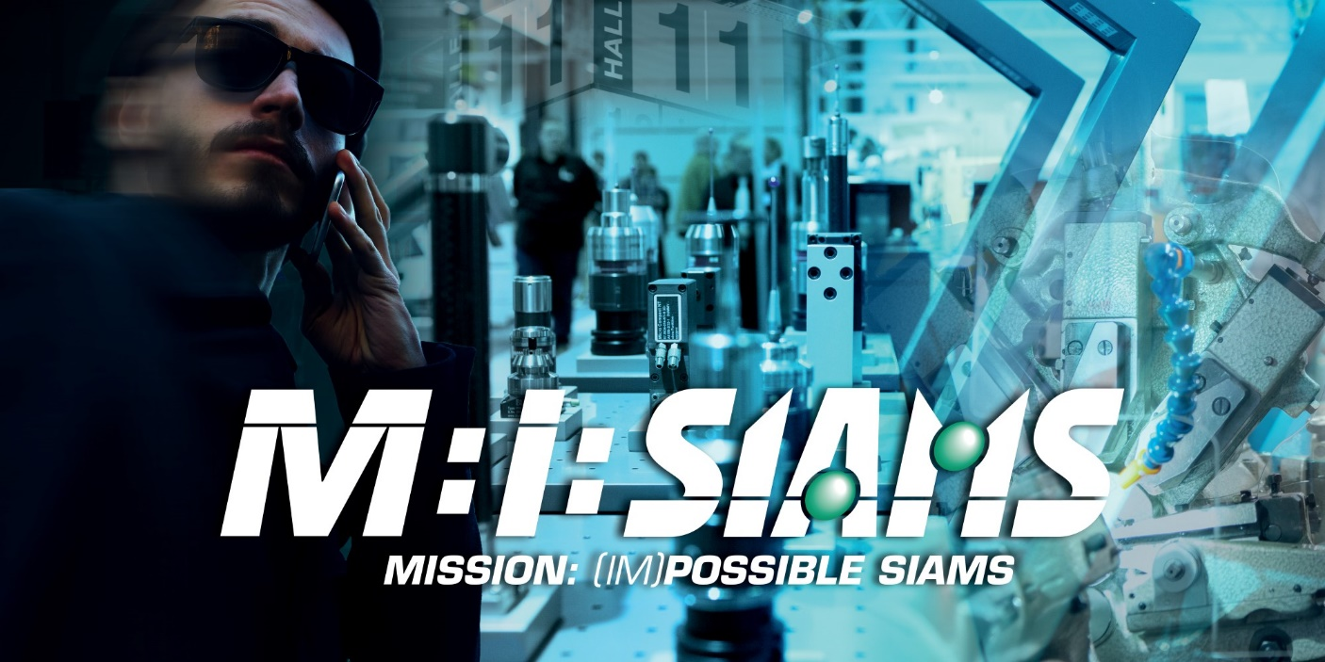
Title image without caption

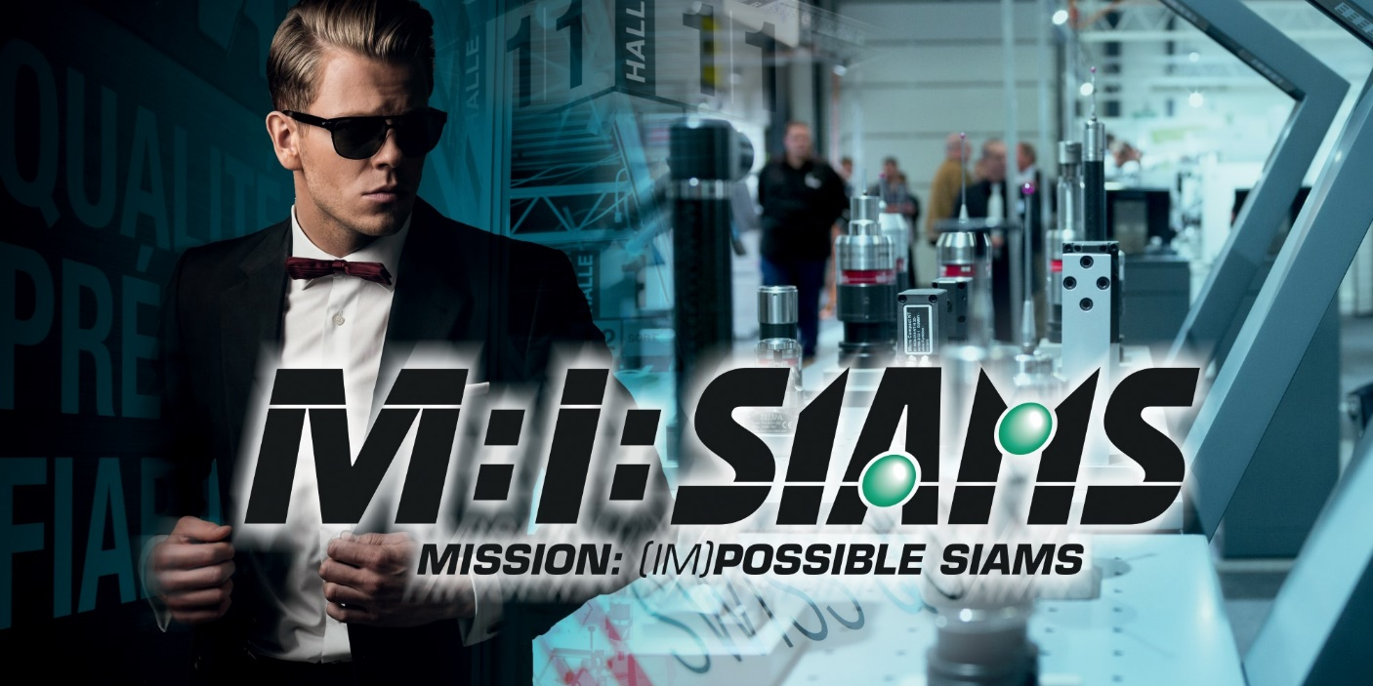
Alternative title image without caption
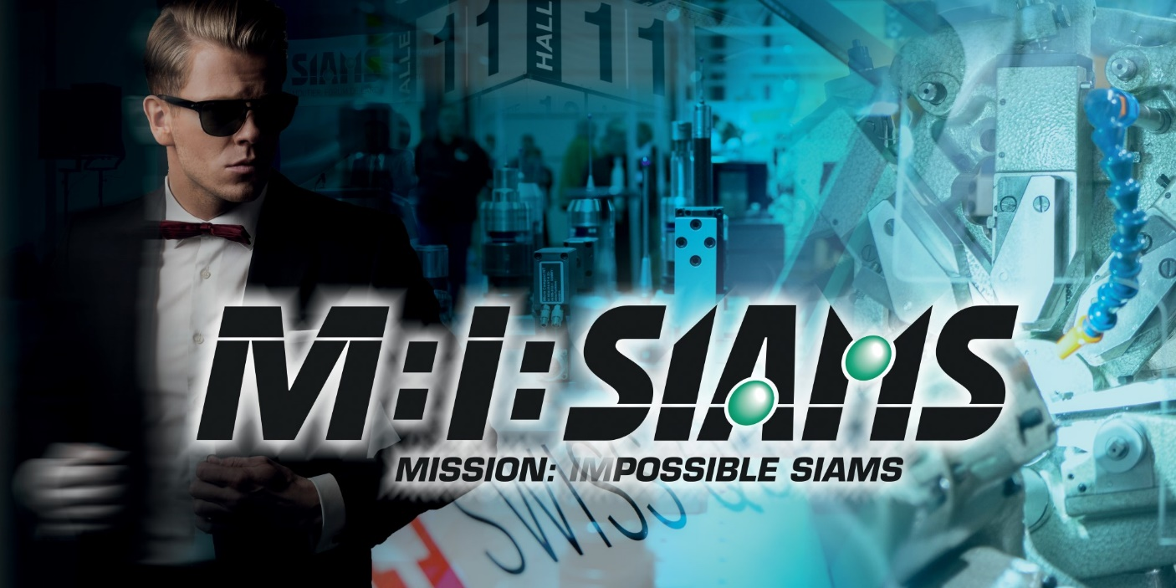
Alternative title image without caption

Do like Agent Hunt, there is still time to plan a visit to SIAMS.
The solutions stamped "SIAMS - World Capital of Microtechnology" can be found all over the world.

Actual name known to the editors.

