Installation of an e-mail footer
“Publication of your News on the SIAMS website”

Proceed as follows to install an e-mail footer called “News on the SIAMS website”.

Open a new e-mail window and select “Signatures”.
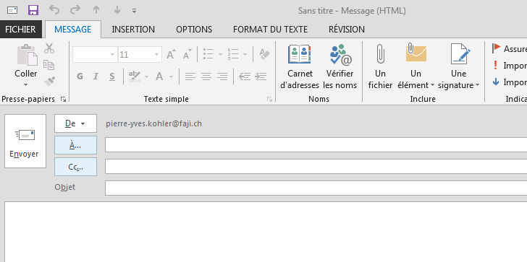

Click on “Signatures” and select “New” in the window that opens:
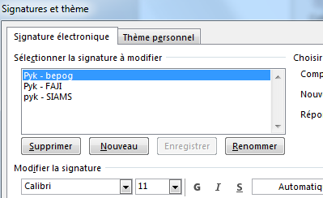

Give your new signature a name and confirm with OK: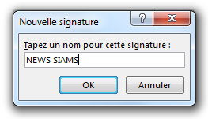

Copy the box below (text and logo).
We have published News on the website of
Don’t miss this:

And paste it into the “Signature” window:
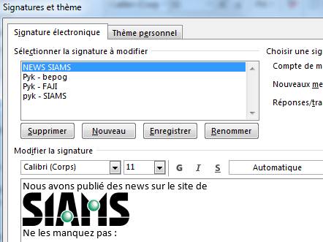

Add the link on your page on the SIAMS website which summarizes the News you published on the site: Why visit / List of Exhibitors / click on your company and copy the address in the browser.

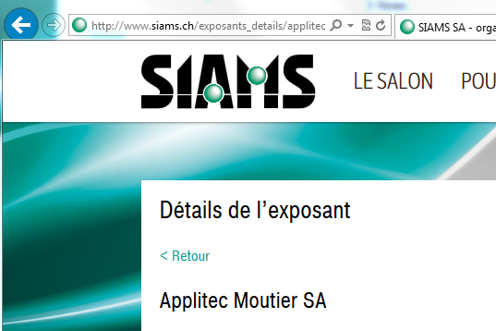

Paste this link into the “Signatures” window on a new line after “Don’t miss this”: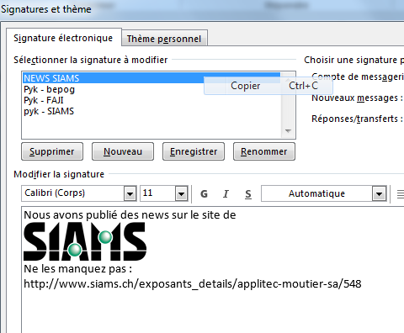
Click on “OK” at bottom right: 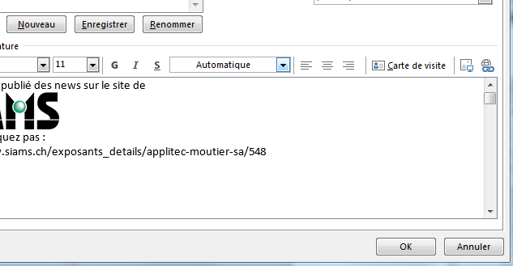
You can now send your e-mails as usual and before sending them, select the newly created signature here:
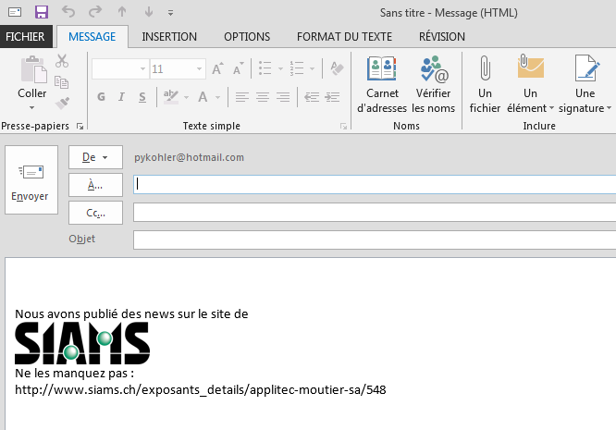
it will now automatically appear at the bottom of your message.

We look forward to see your News on the SIAMS website.

