E-mail or letter
“Invitation to SIAMS 2026 in Moutier”

Subject: invitation to SIAMS 2026 in Moutier

Dear customers

You would like to …indicate a customer issue here.
Come and discover product YY at stand XX/Hall ZZ. This innovation allows you to…. Indicate a customer benefit here.
Take advantage of our presence at SIAMS to find out more and have a good time with us!

From April 21st till 24th, 2026, Moutier (Bernese Jura, Switzerland) will be transformed into the world capital of micro and precision engineering. The fair still has a reasonable size and allows us to optimally present ourselves in a hospitable and friendly ambiance.

We are pleased to invite you to this fair, which represents the entire production chain of microtechnology.

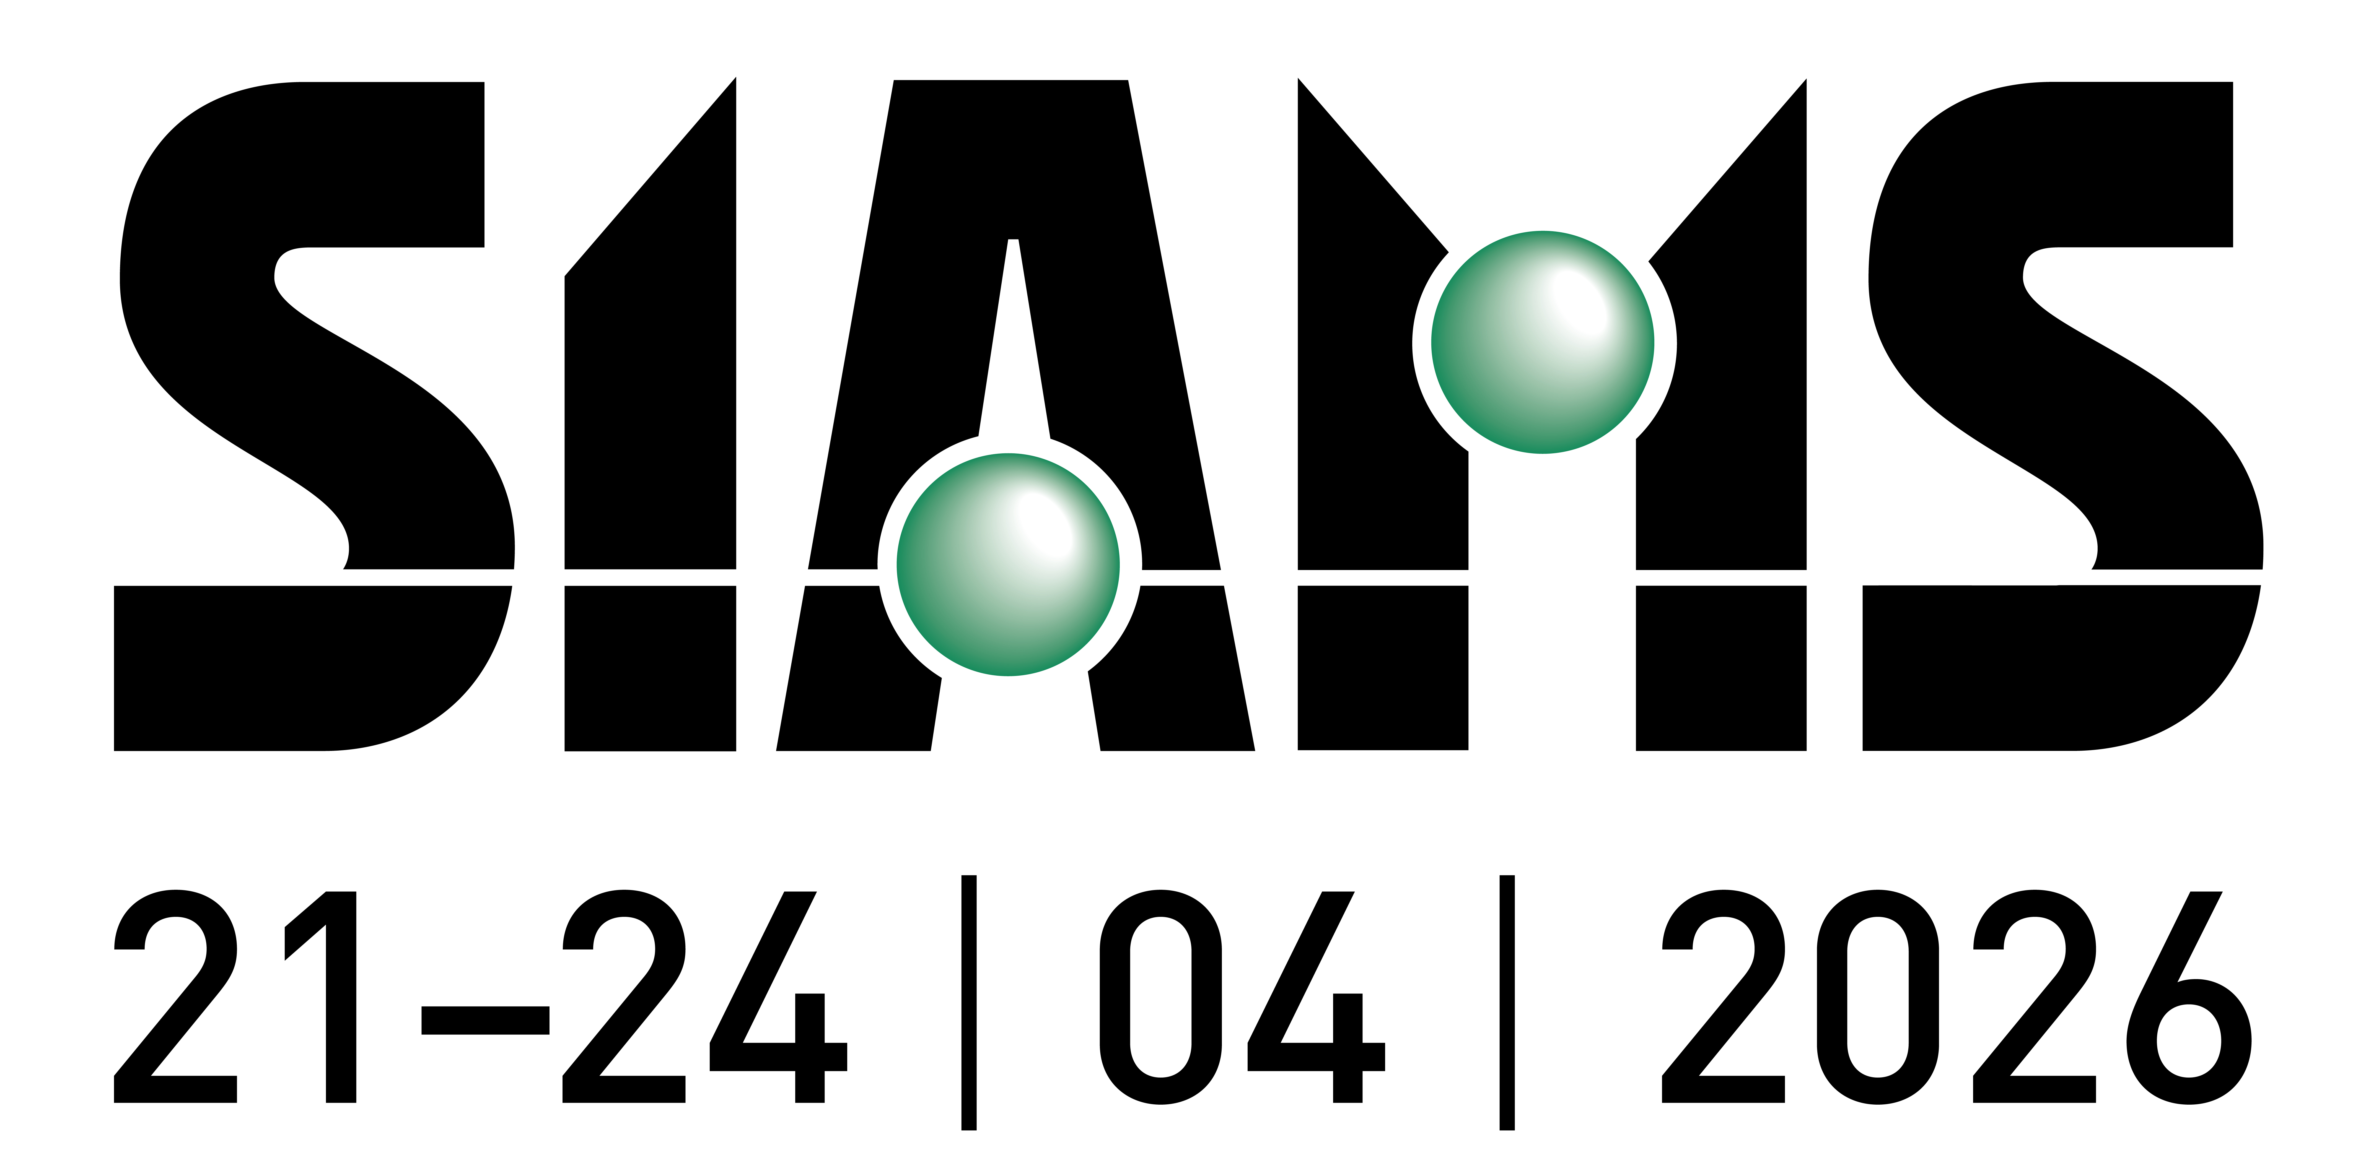

You will find us at booth XX in Hall YY.

We shall take advantage of our presence in the midst of this trade fair to present product X or Y offering you the following advantages:
- advantage A
- advantage B

(Here you can, for example, include the content of your personalized poster. To create your personalized posters, see the tutorial here: Tutorial: how to create a personalized poster)

You can also include a link to your personalized home page, see the tutorial here: Customised home (and invitation) page available for the 2026 edition.

We are looking forward to meeting you at this important event.

The fair can easily be visited in a single day, but if you wish to book a hotel, you can contact Jura Bernois Tourism, 2740 Moutier, www.jurabernois.ch, tel. 032 494 53 43.

To simplify your visit, the organizers have set up a preparation system that allows you to “put all your contacts in one basket” and print the list to take on site. Do not forget to add us, too.

Explanations available from: A powerful tool to plan your visit to SIAMS.

Kind regards,

(Signature)

P.S.: From February 15th, 2026, you will be able to download your complimentary ticket from the SIAMS website: www.siams.ch/tickets

